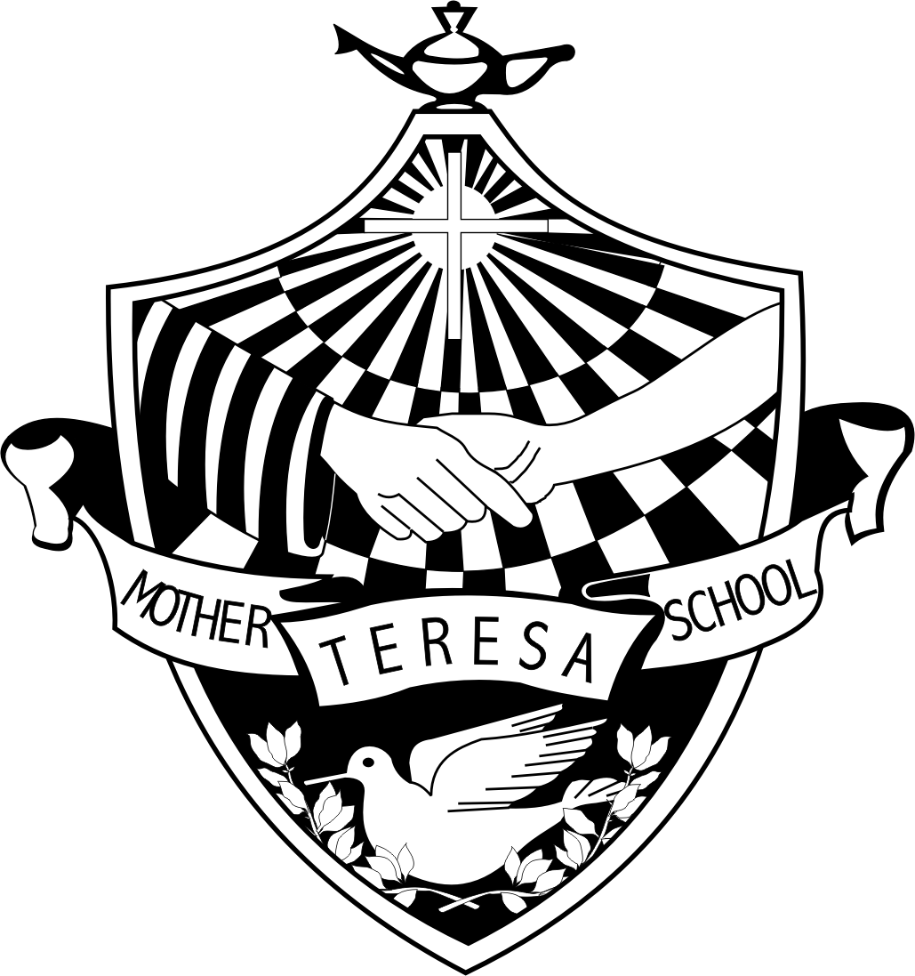
Mother Teresa Catholic School’s
Meet & Greet
BBQ & OPEN HOUSE
Wednesday, September 26th, 2018

Why: To provide an opportunity for families to meet staff members and other families in the Mother Teresa Catholic School Community.

When: Wednesday, September 26th, 2018
5:30 – 6:00 p.m. - BBQ sponsored by Mother Teresa Catholic School Council and supported by St. Paul the Apostle Knights of Columbus Chefs! Menu will consist of a hot dog and drink.
6:00 – 7:00 p.m. - Visit classrooms, meet teachers, greet fellow classmates and families.

Where: Mother Teresa Catholic School Backyard and Foyer. (if rainy front yard and foyer)

Who: Let us know if you plan to attend by signing the tear-off form below and returning it to the school by Monday, September 24th, 2018

Please return this form to the school by Monday, September 24th, 2018

The ______________________________________ Family plans to attend the Meet & Greet BBQ and Open House on Wednesday, September 26th, 2018


# of family members attending: _______________

# of hot dogs: _______________
# of “Veggie” dog: _______________

Parent/Guardian Signature: _________________________________________

